Exit Pass

Name : ____________________

Question 1
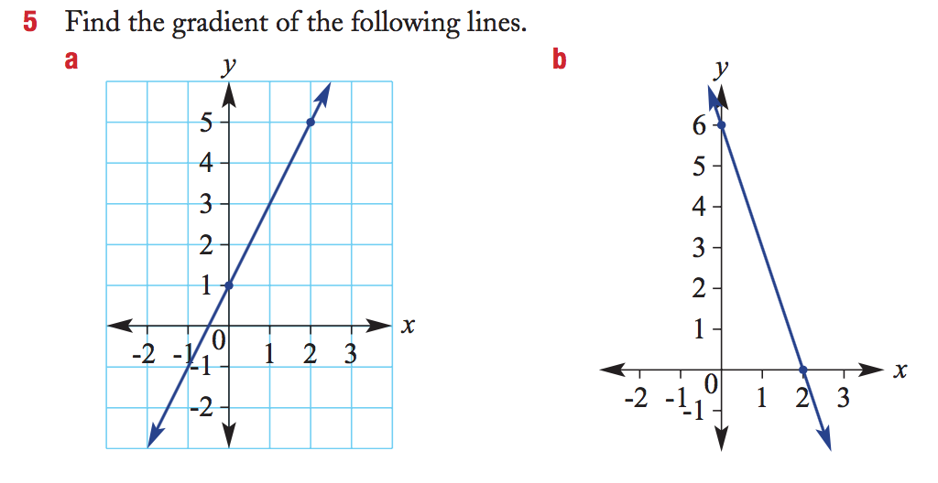
Question 2
Plot a line with a gradient of 5 that goes through the point (1 4)
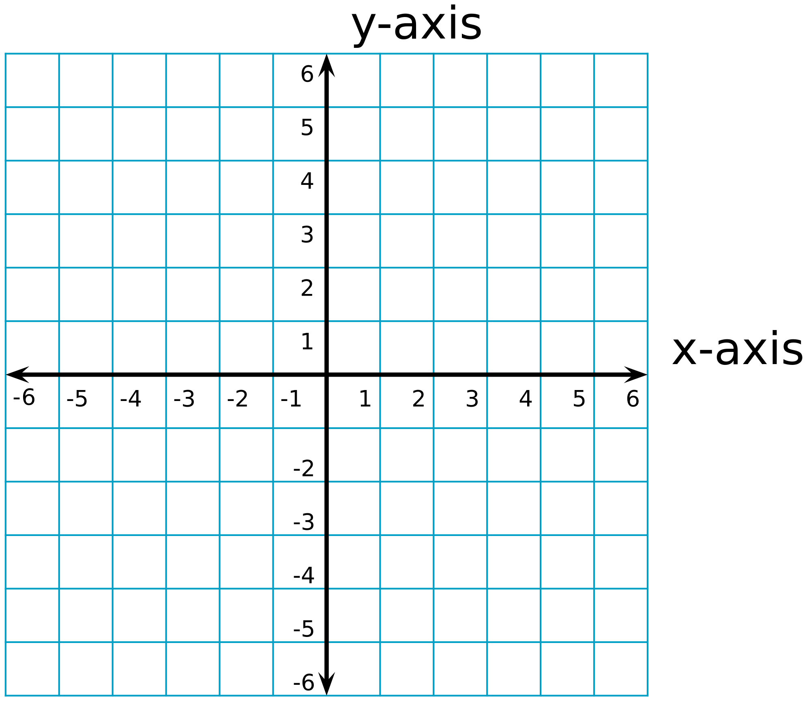
Exit Pass

Name : ____________________

Question 1

Question 2
Plot a line with a gradient of 5 that goes through the point (1 4)


